**Virtual Box**

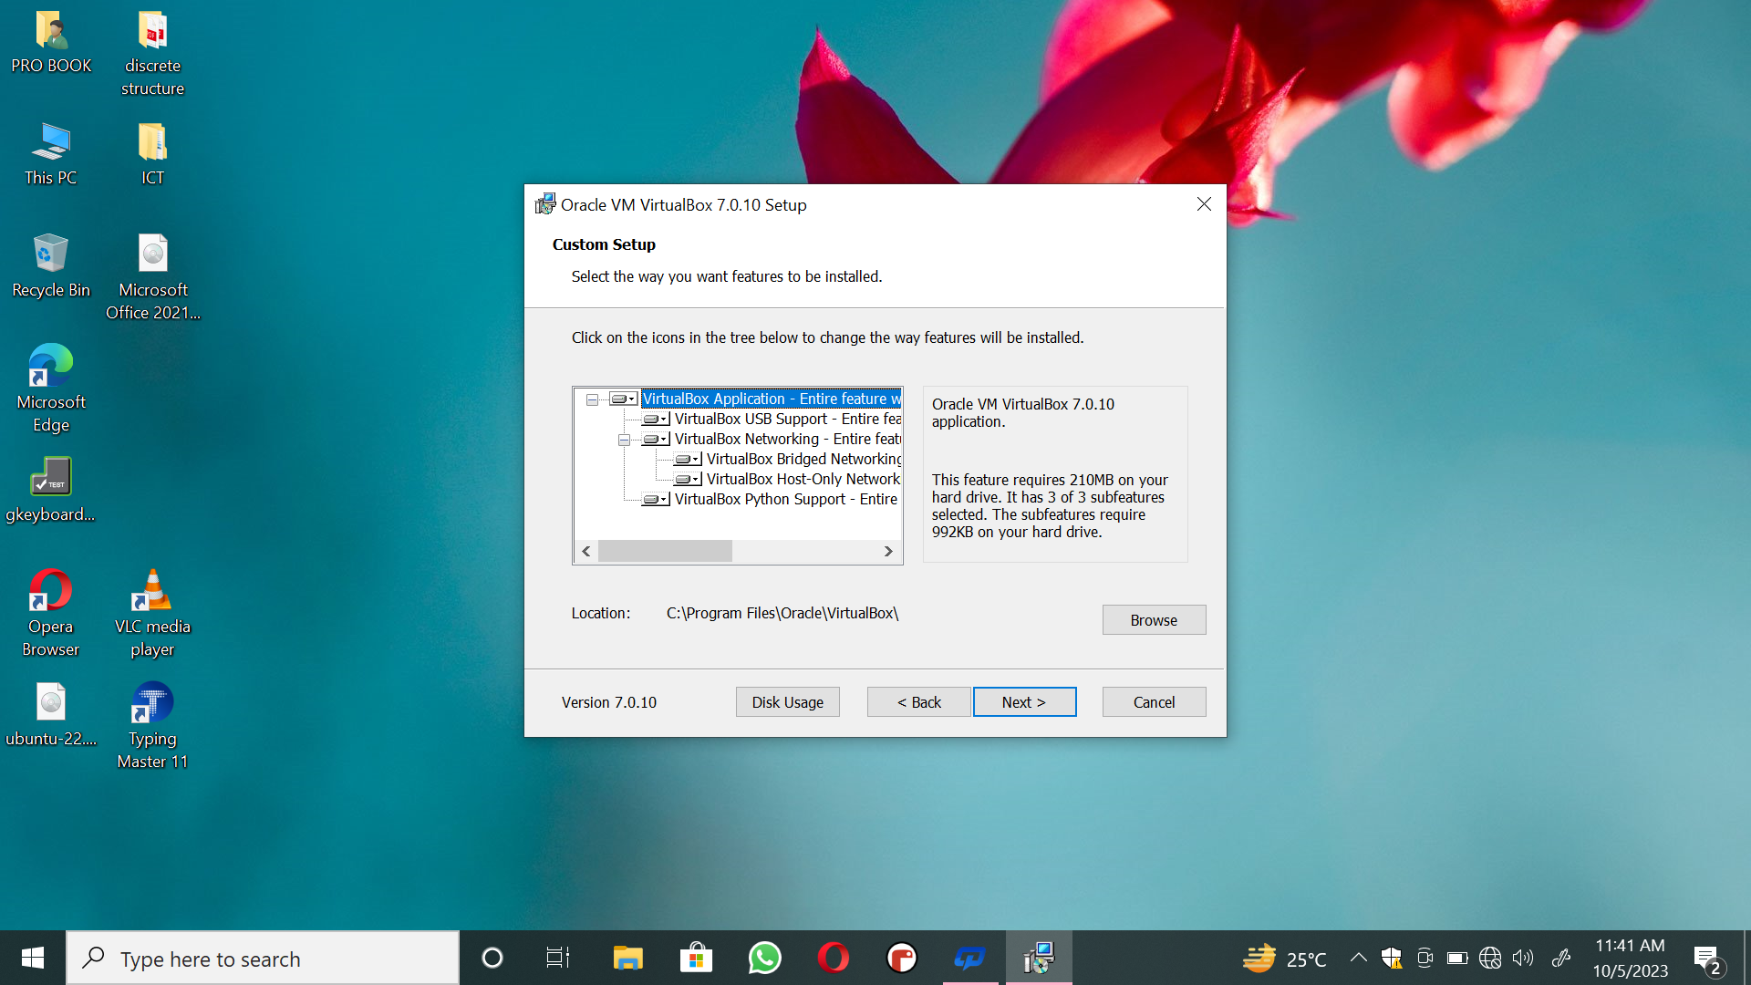

**Ubuntu**

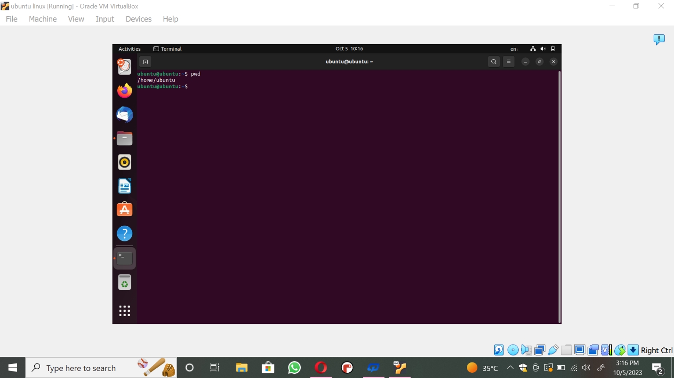

**Task # 3**

**Help:** **It is used to call for help.** 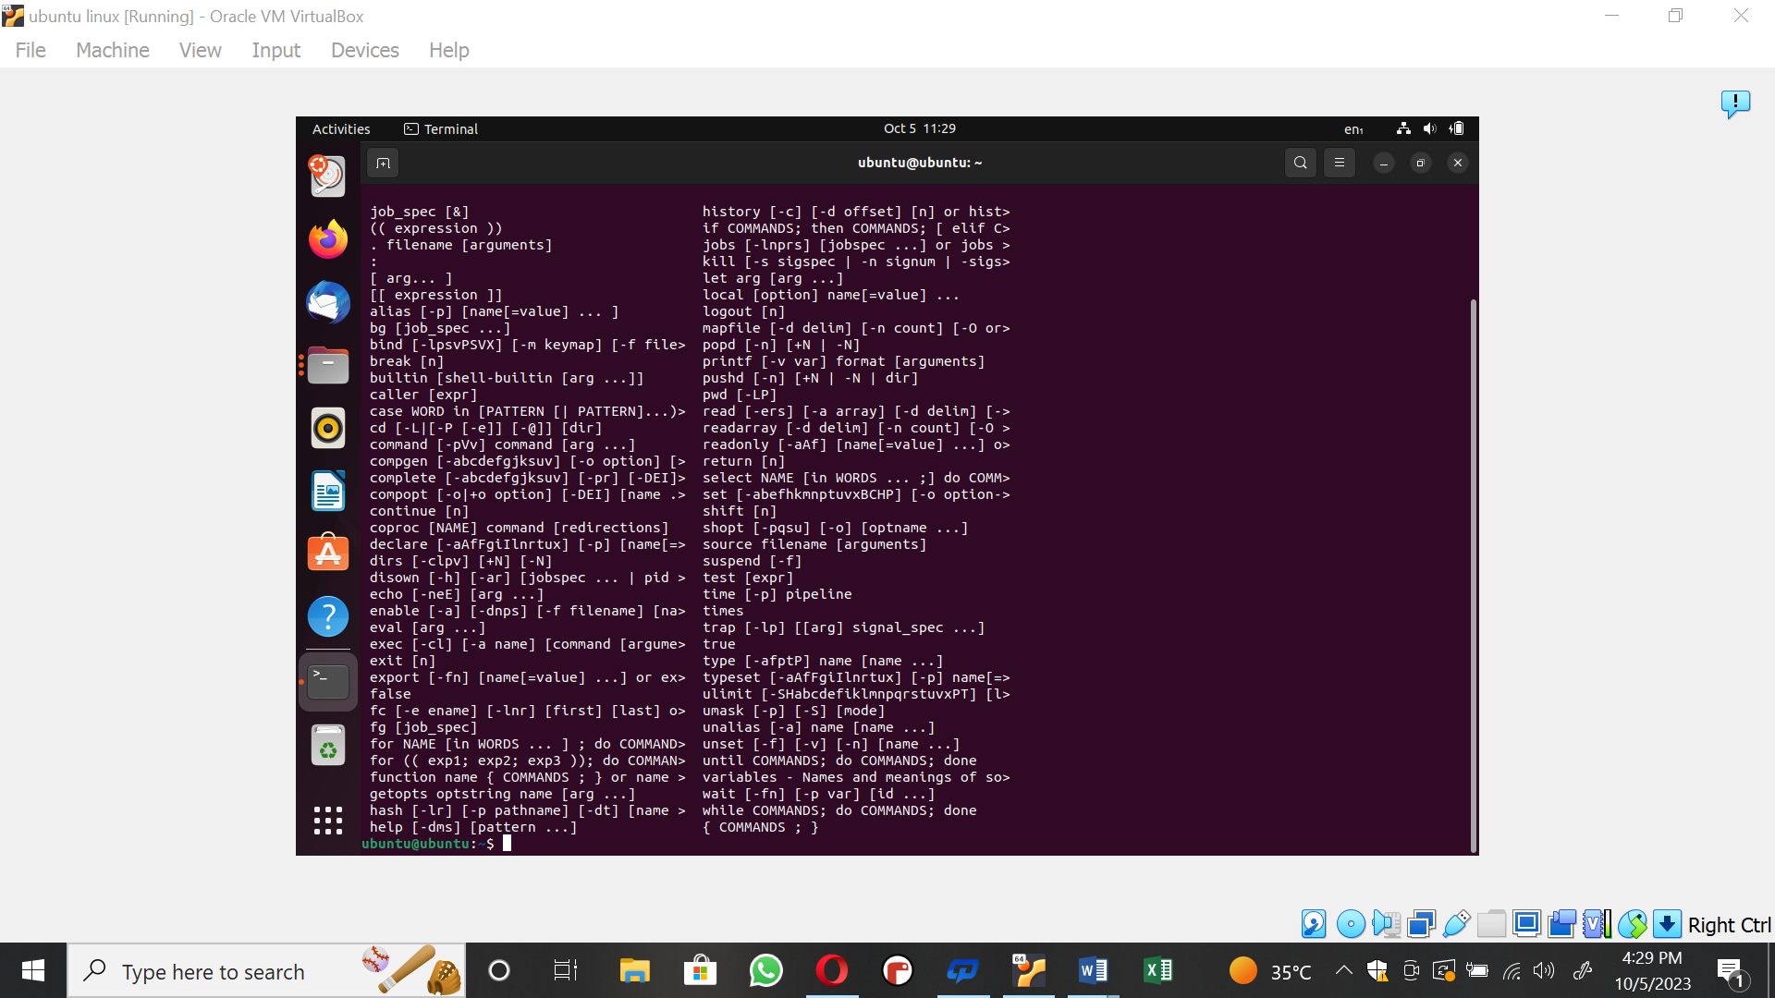

**Mkdir:**

To directory Linux has command “mkdir” stands for 'make directory'. With the help of

“mkdir” command, you can create a new directory wherever you want in your system. Just type

"mkdir <dir name>”, in place of <dir name> type the name of new directory, you want to create and then press enter.

**Syntax:**

~$ mkdir <dirname>

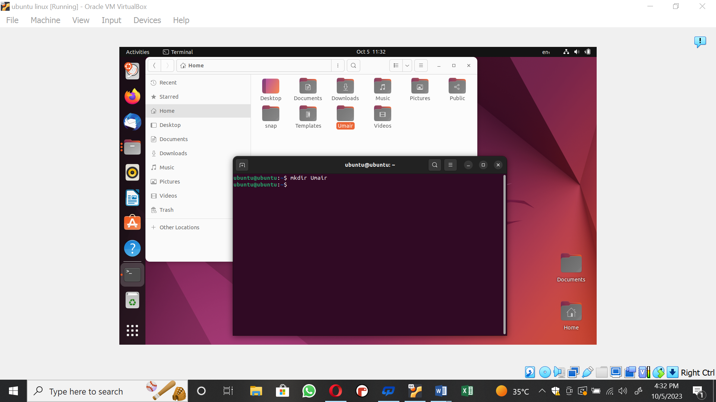

**Cd , cd ..**

The command cd directory means change the current working directory to “directory”. The current working directory may be thought of as the directory you are in, i.e., your current

position in the filesystem. To change to the directory you have just made, type.

To change current working directory, use command “cd <next-directory>”.

It is showing how to change current working directory which is home directory to next

directory which is “Desktop”.

**~$** cd Desktop

To go up one level in the directory tree, use two dots.

**~$** cd ..

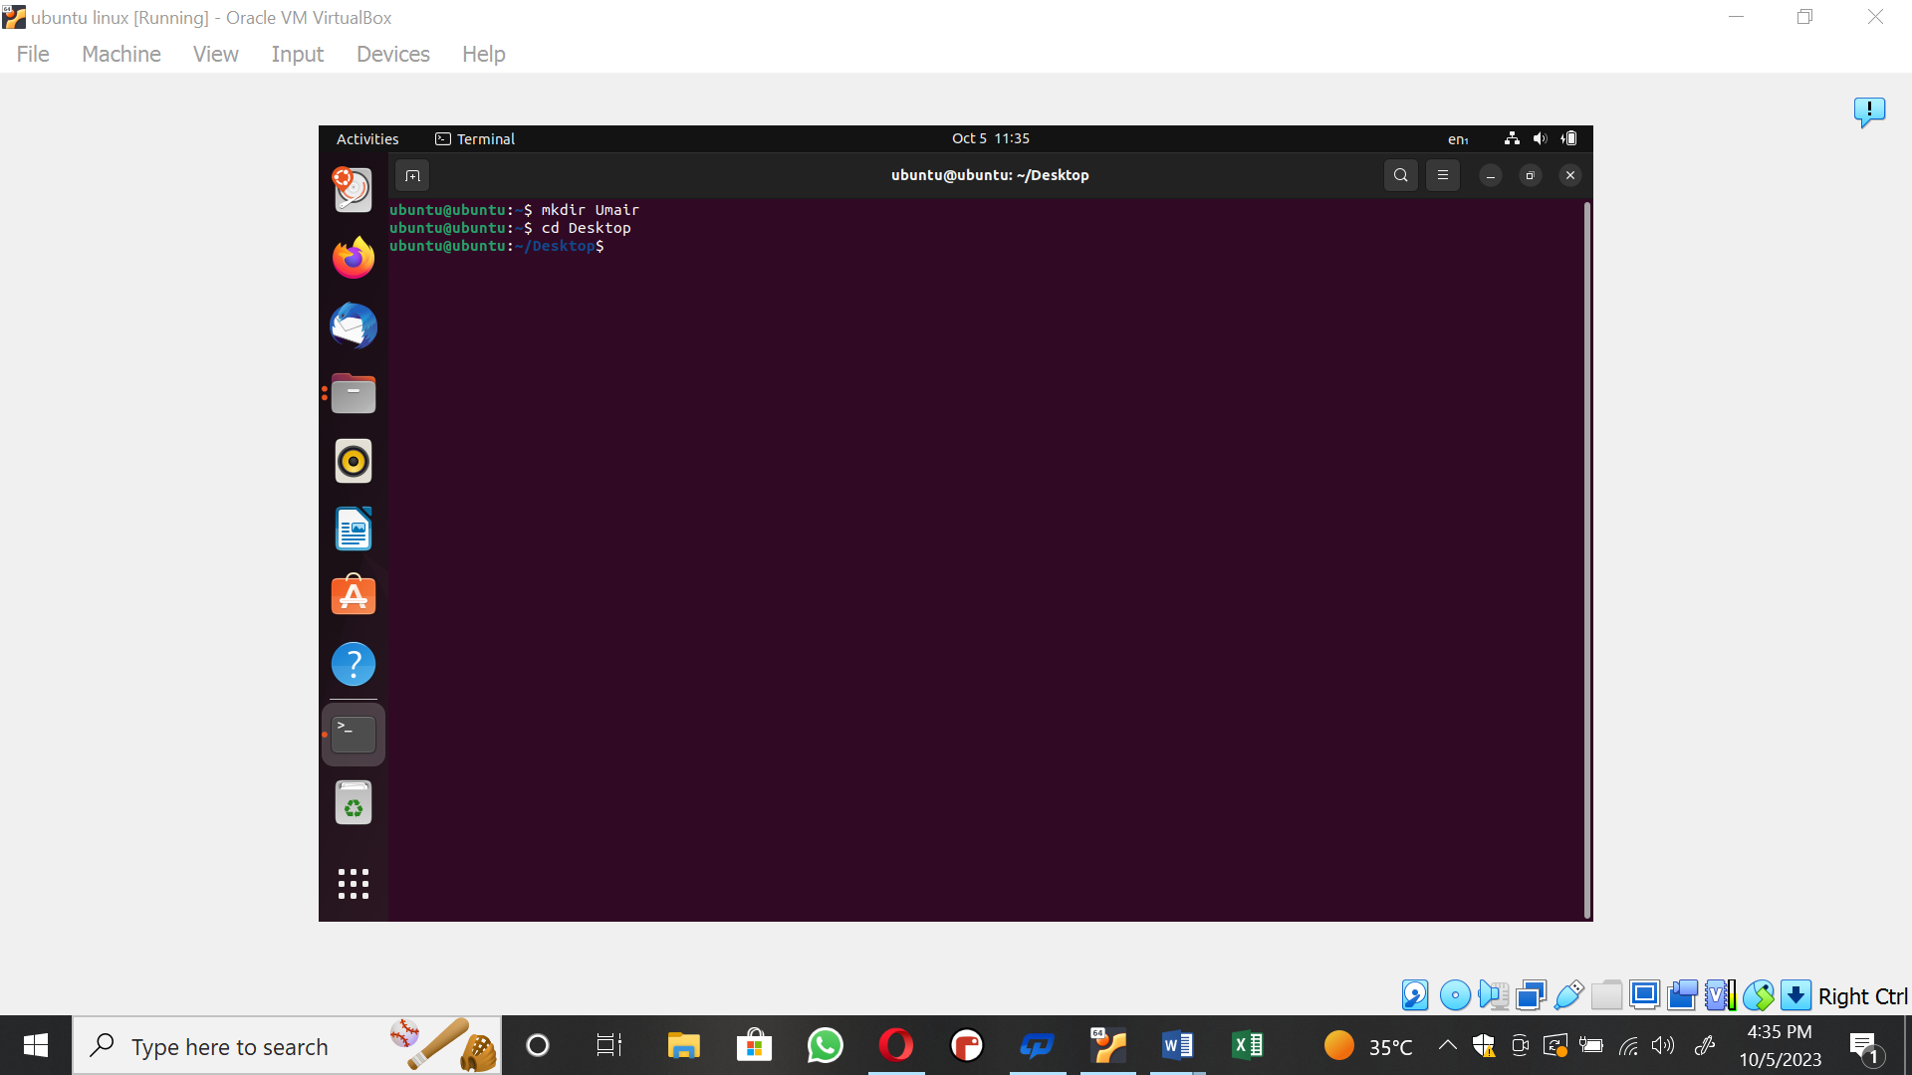

**Cd~:**

~**$** cd ~

In Linux systems, the tilde (~) character represents your home directory.

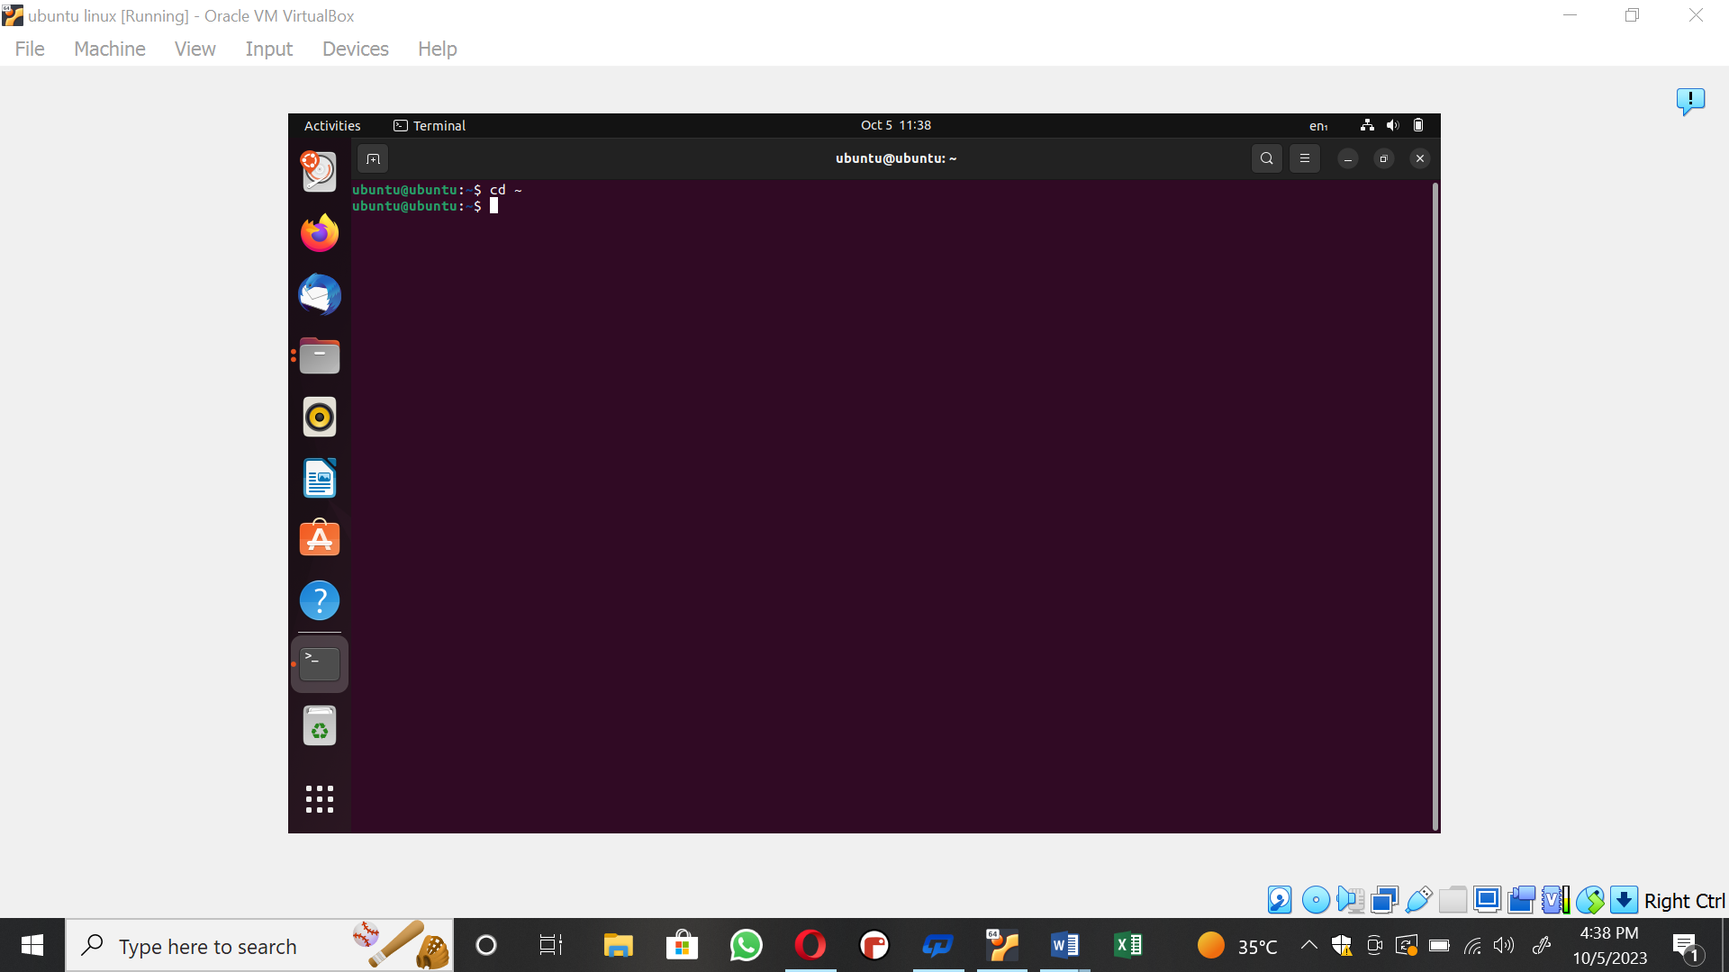

**ls:**

To find out what is in your home directory, use the “ls” command. (ls is short for "list").

There may be no files visible in your home directory, in which case, nothing will print but the

command prompt again.

List contents of your current working directory:

**~$** ls

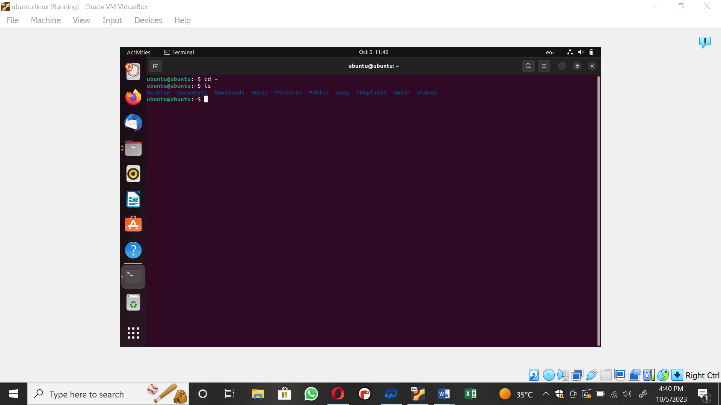

**Rm my file**

Removing Directories with rmdir:

“rmdir” is a command-line utility for deleting empty directories. It is useful when you want

to delete a directory only if it is empty, without needing to check whether the directory is empty

or not. To delete a directory with rmdir, type the command followed by the name of the directory

you want to remove. For example, to delete a directory named dir1 you would type:

**~$** rmdir directory

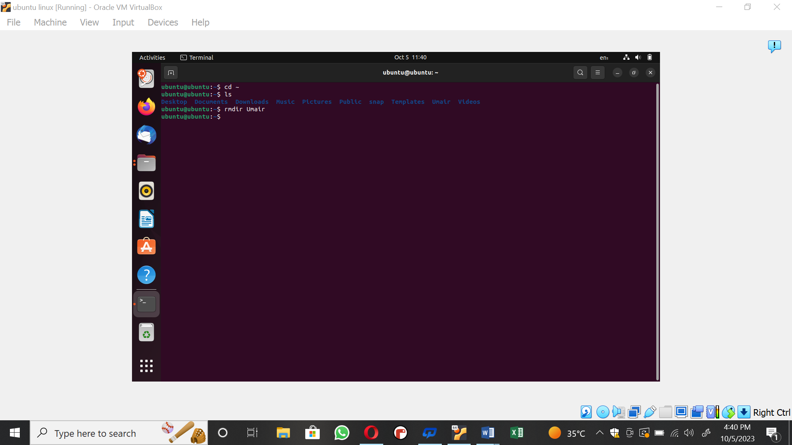

**cp file1 file2**

The “cp” command is the primary method for copying files and directories in Linux.

Virtually all Linux distributions can use “cp”. The basic format of the command is:

**~$** cp source_file target_file

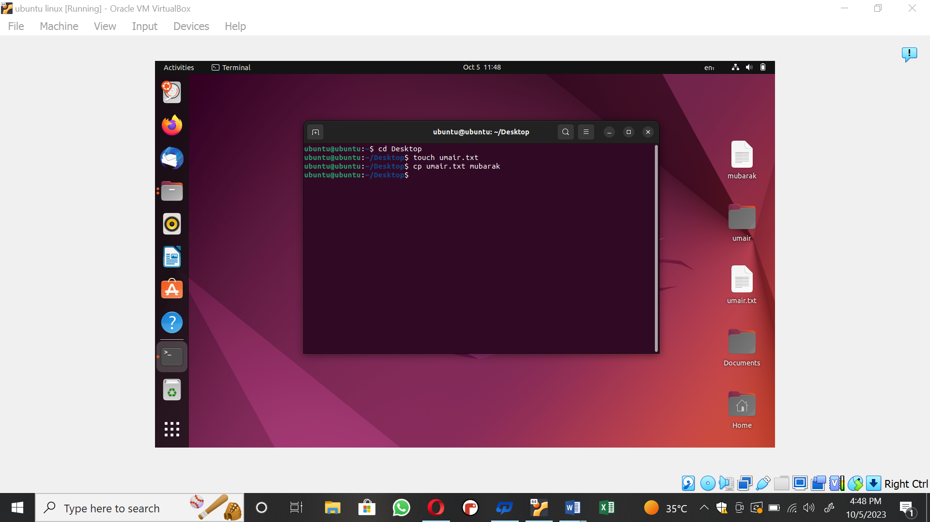

**cat myfile**

The “cat” command is mainly used to read and concatenate files, but it can also be used for

creating new files.

To create a new file run the cat command followed by the redirection operator “>” and the

name of the file you want to create. Press Enter type the text and once you are done press the

CRTL+D to save the files.

**~$** cat > file1.txt

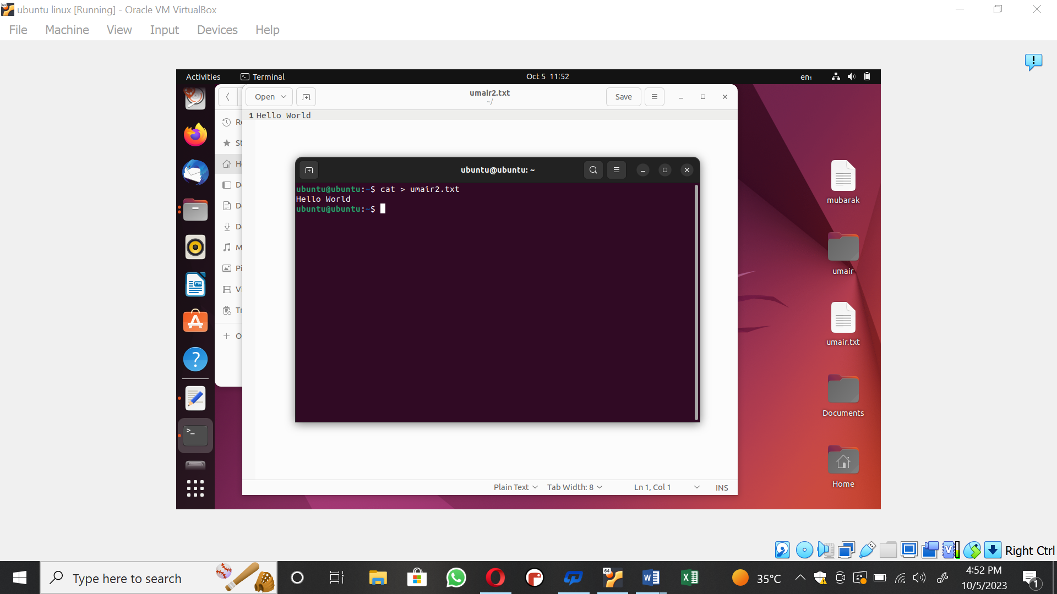

**Task 04**

1. **Make directories of name F1, F2, F3 and F4.** 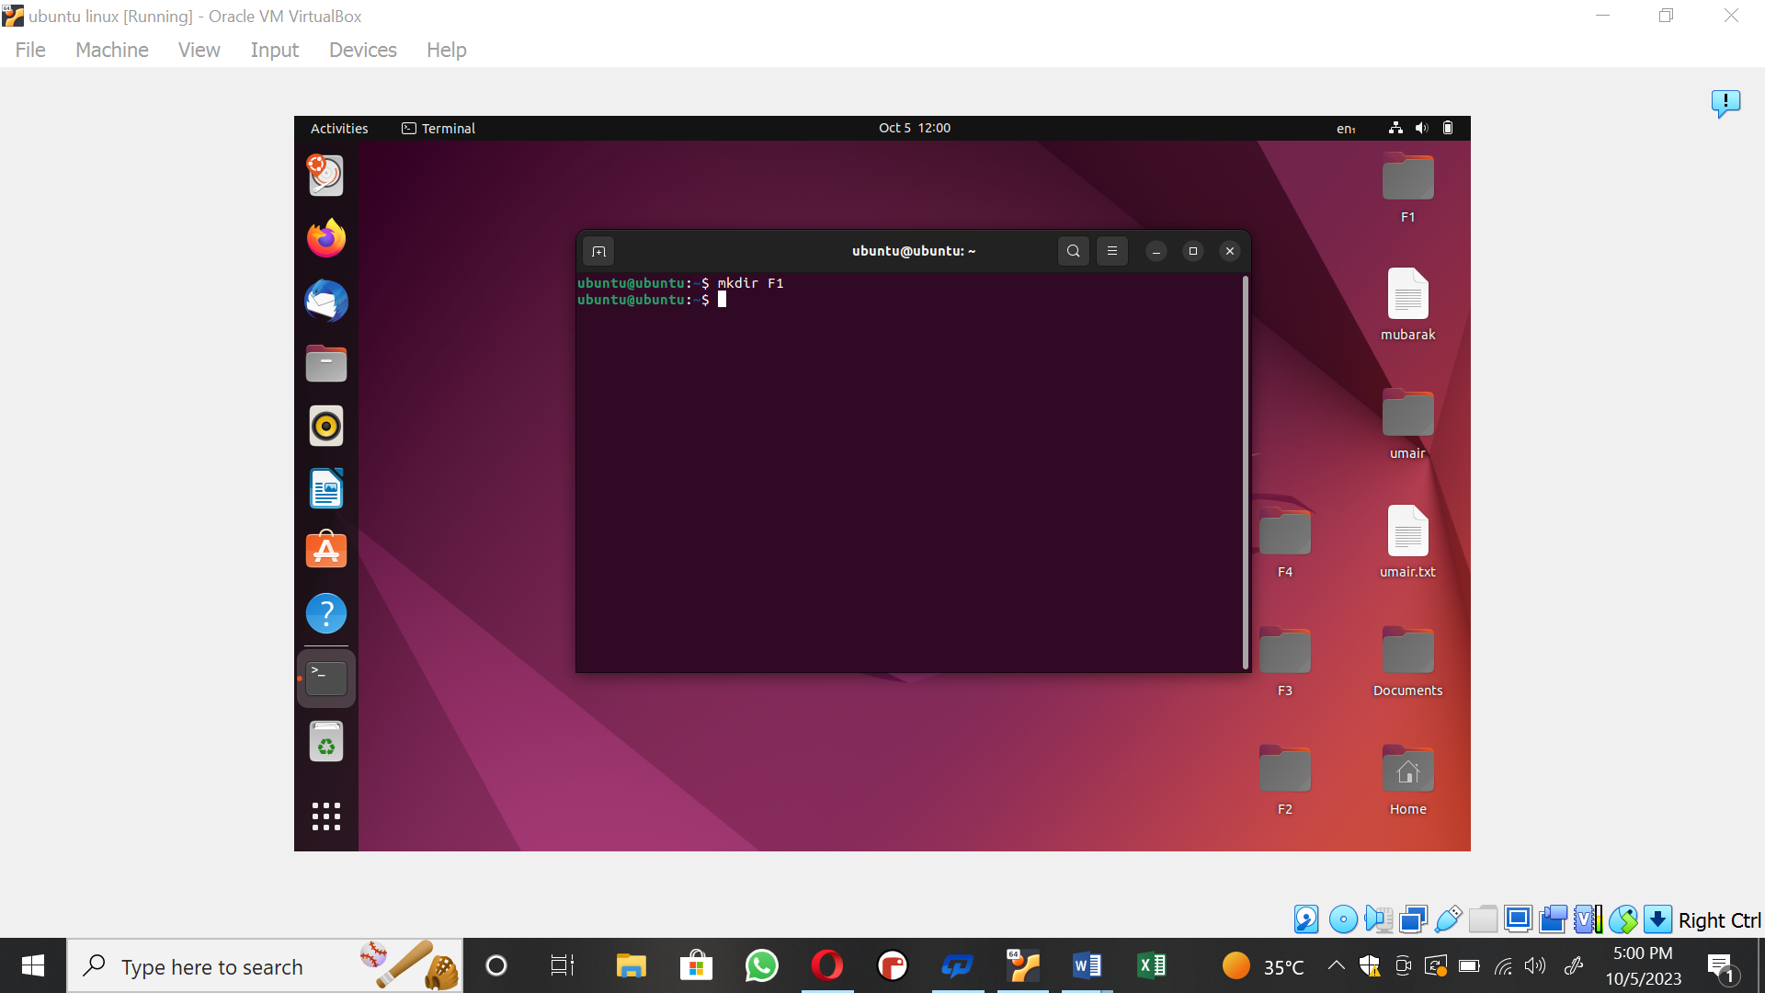

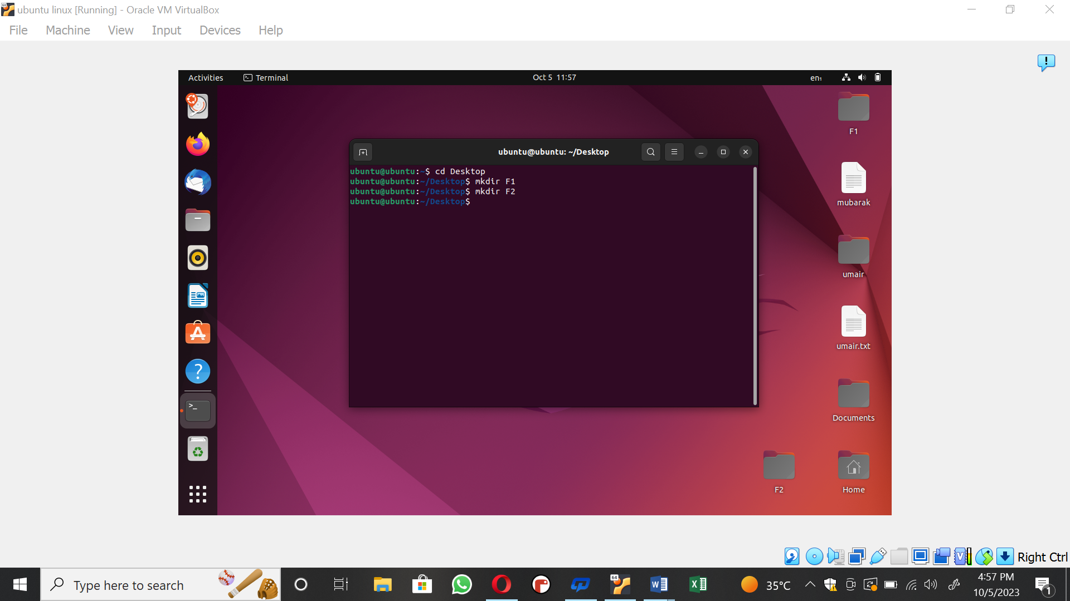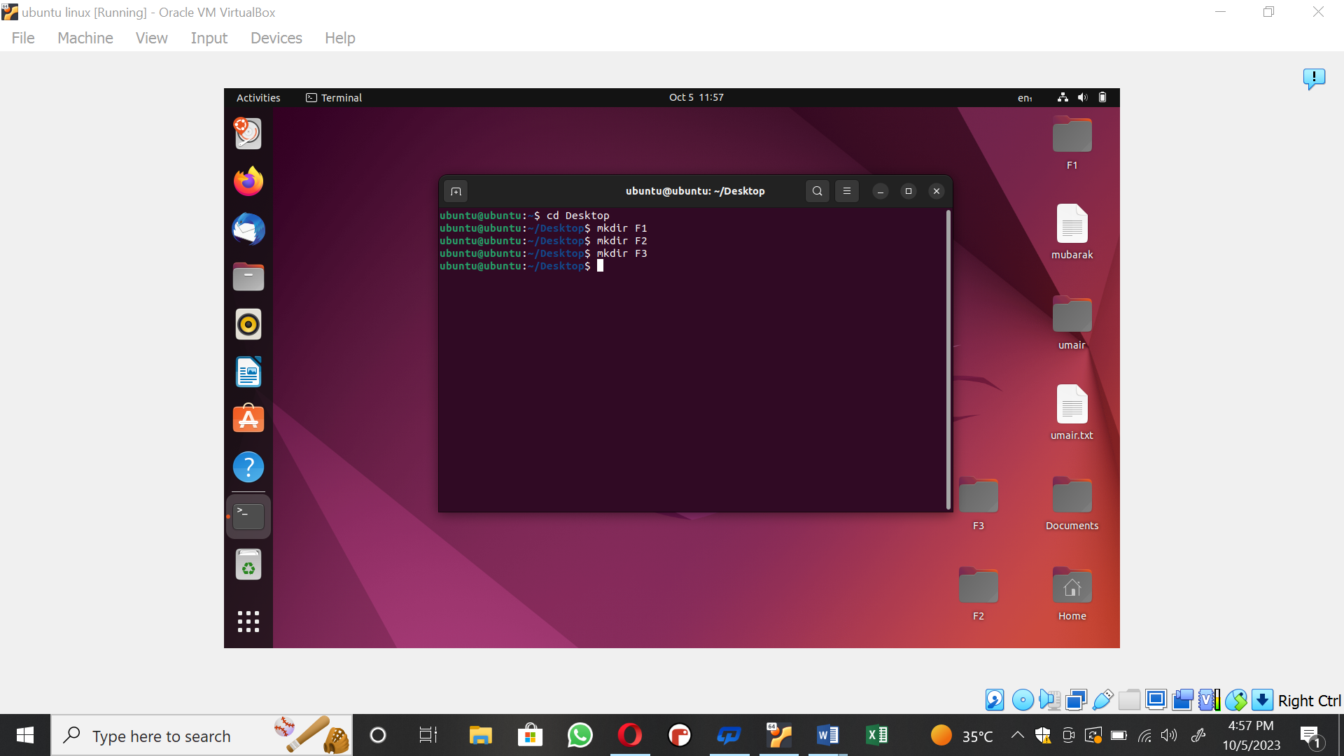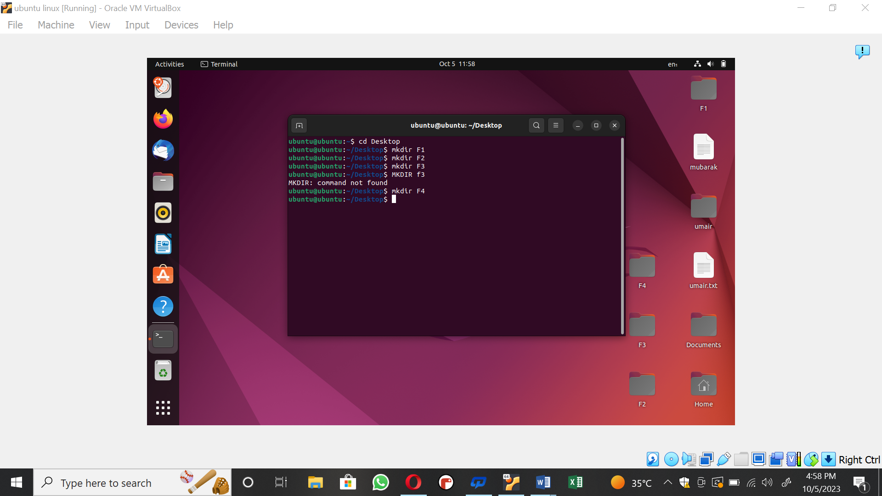

**Make file of named “file1.txt” into directory F1.** 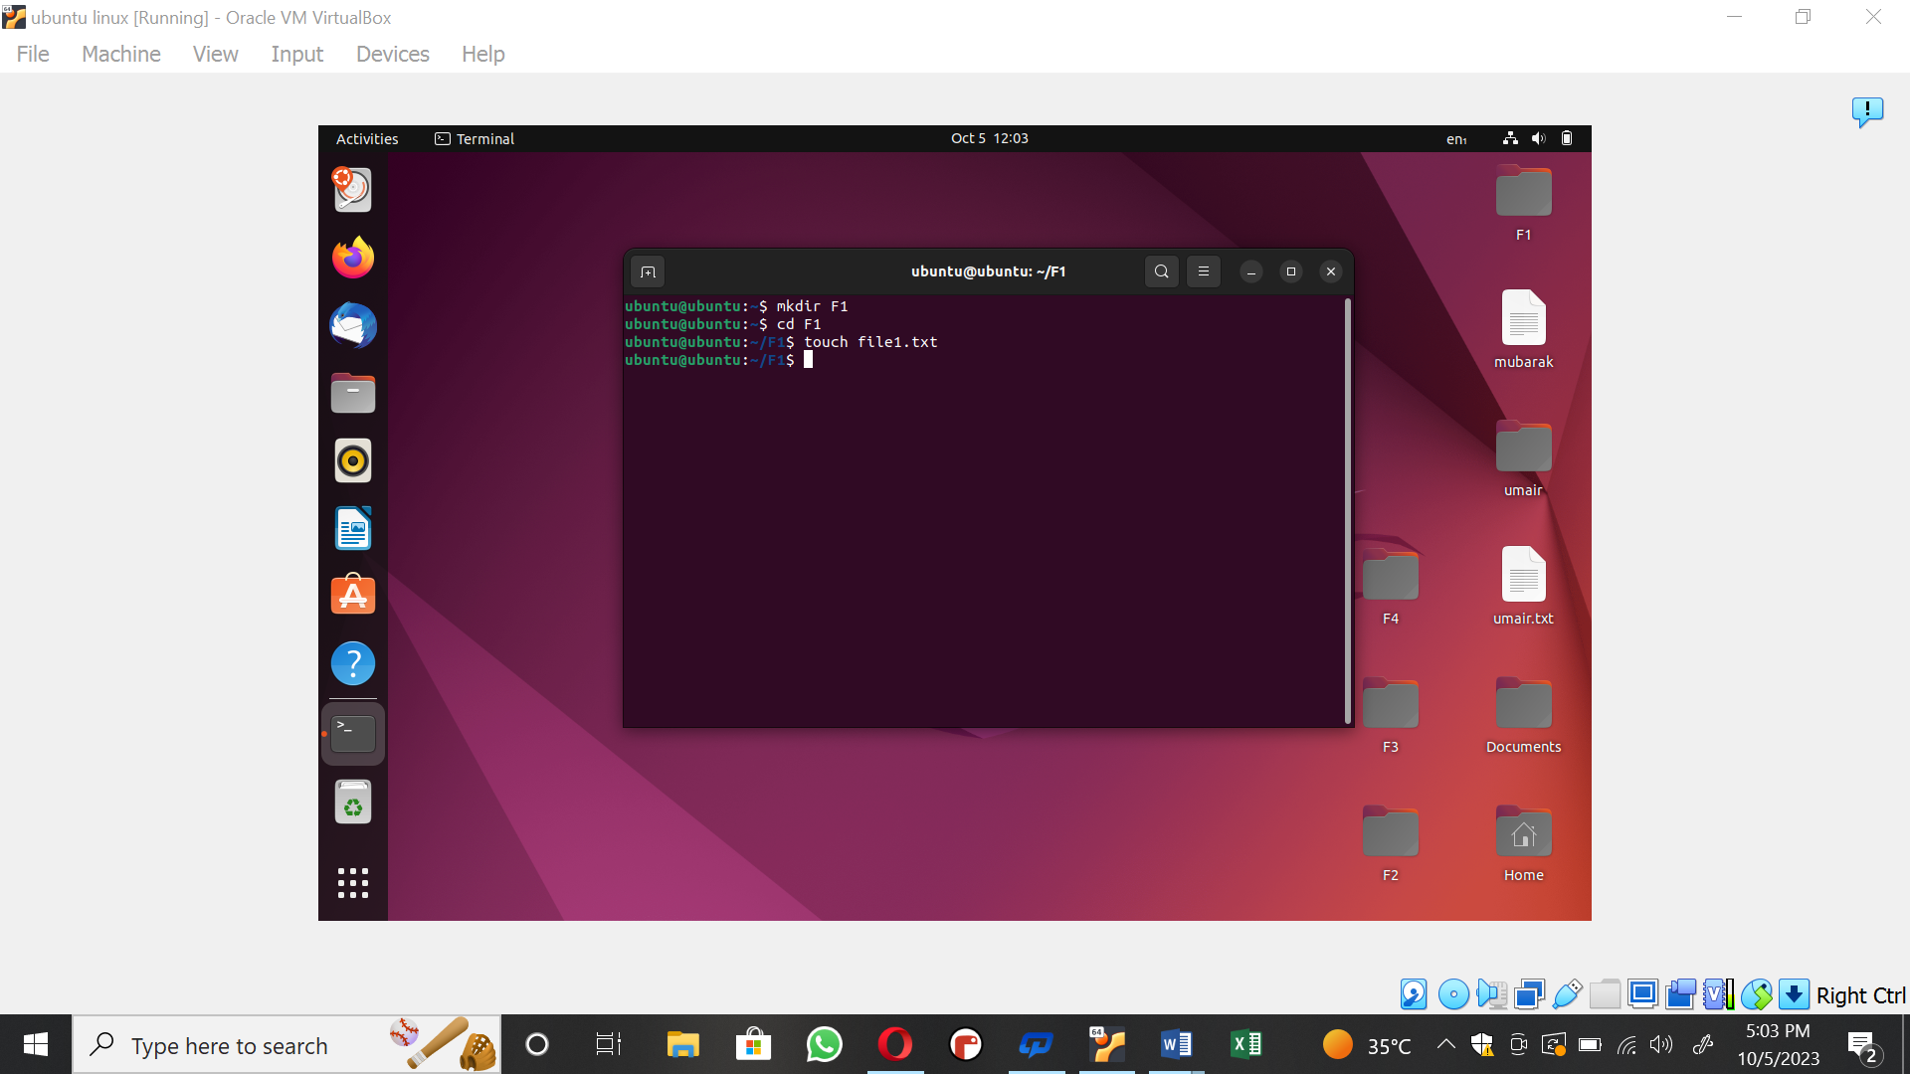

**Make file of named “file2.txt” into directory F2.**

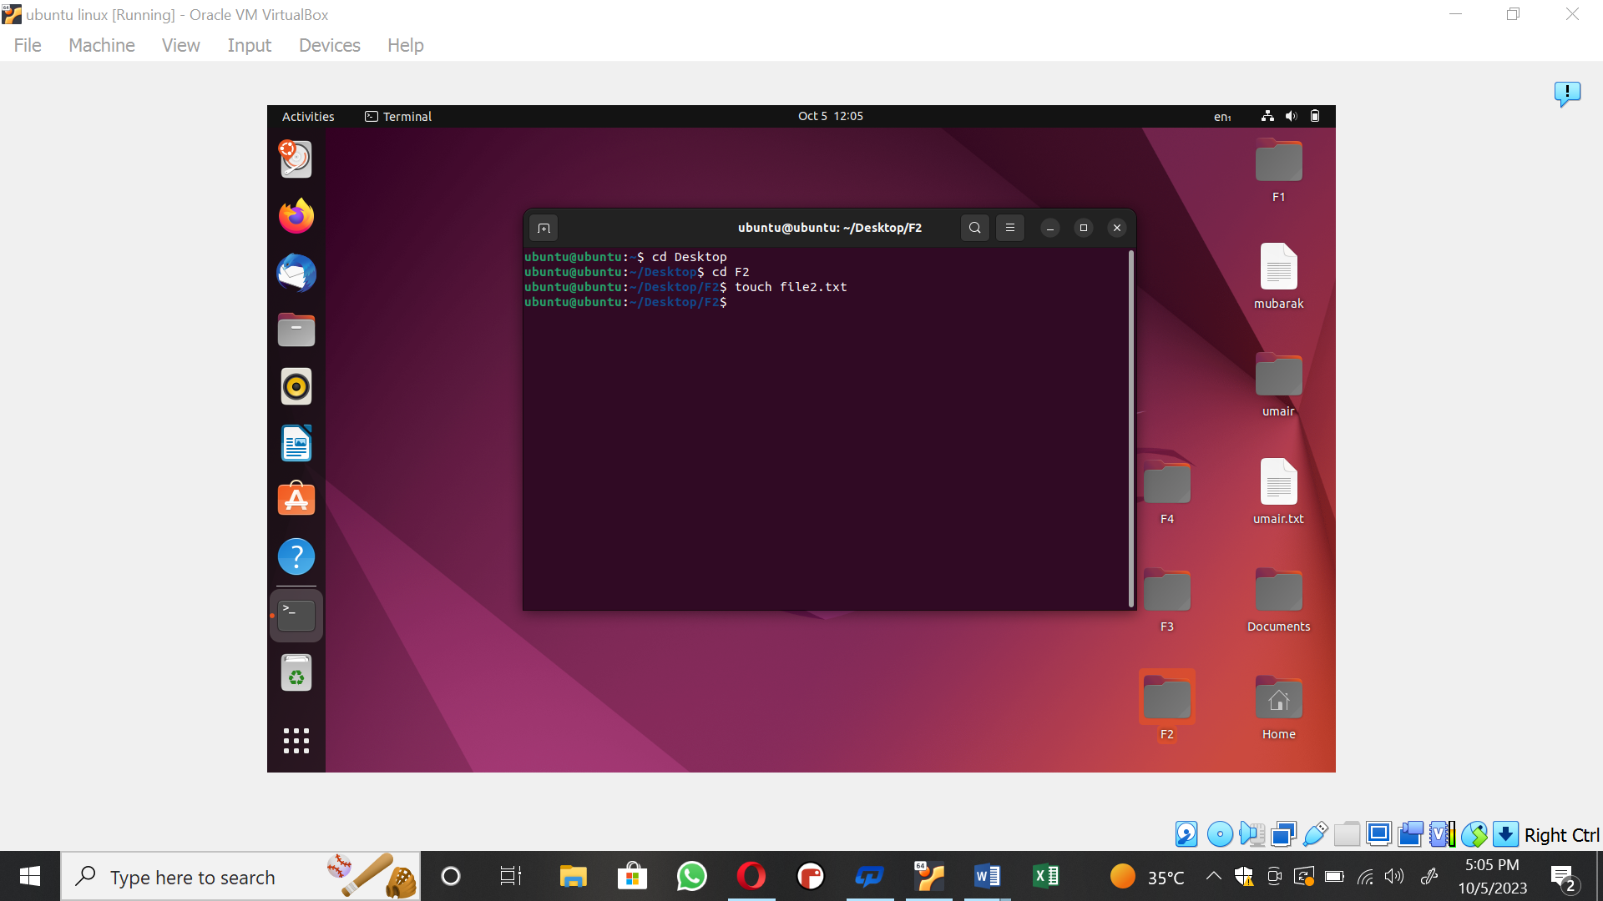

**Make file of named “file3.txt” into directory F3.**

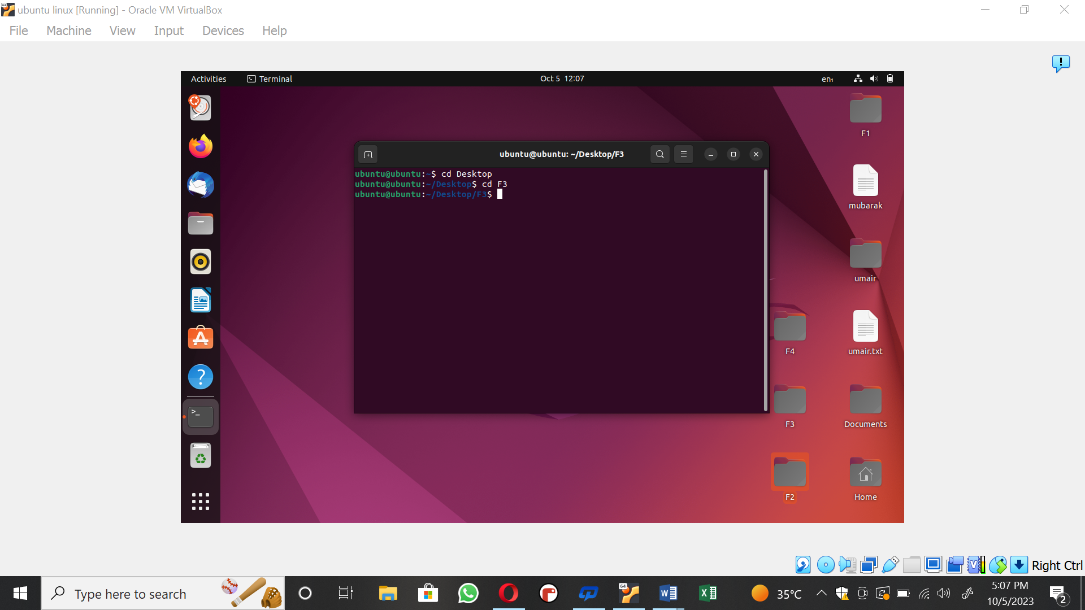

**Make file of named “file4.txt” into directory F4.**

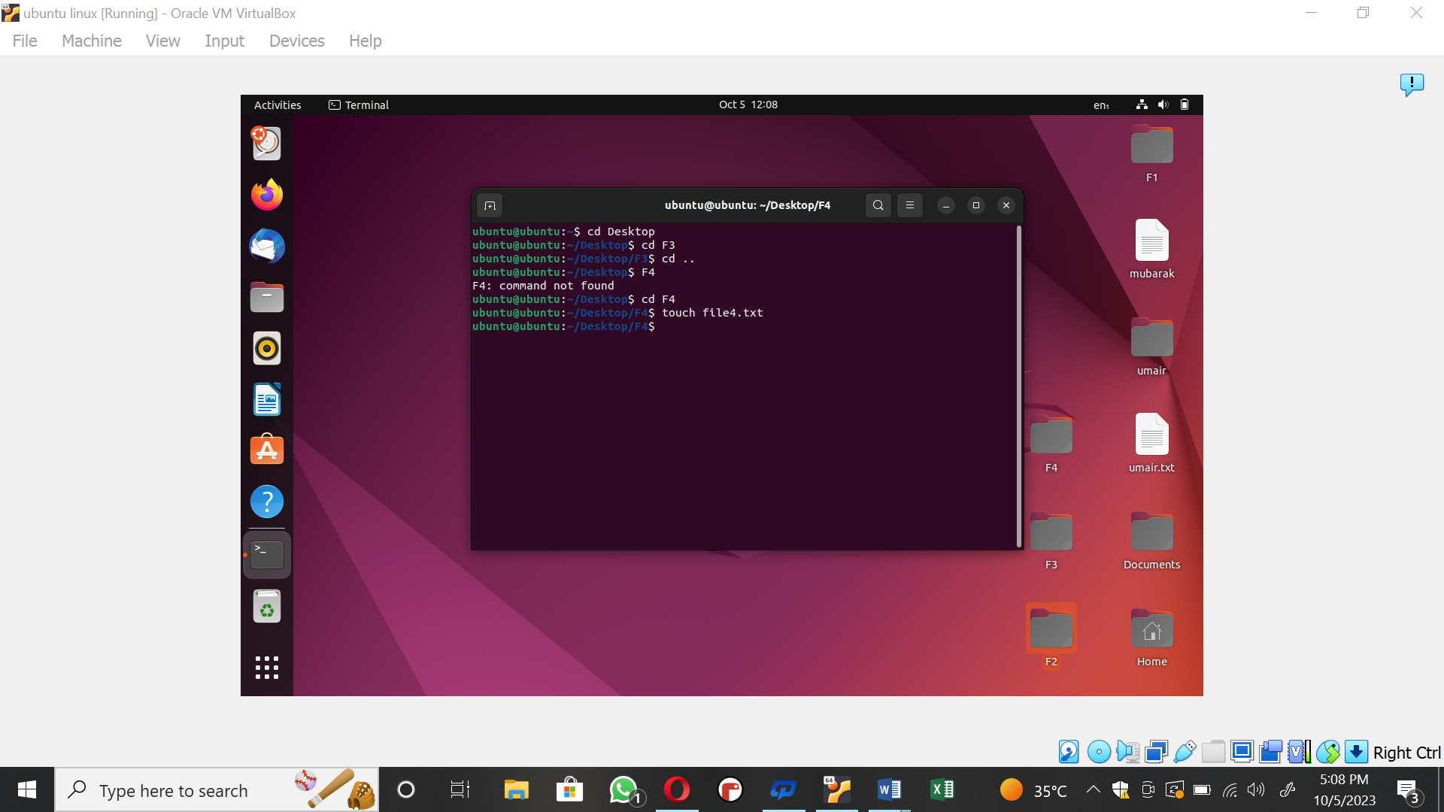

**Move directory F3 into F1 and F4 into F2**

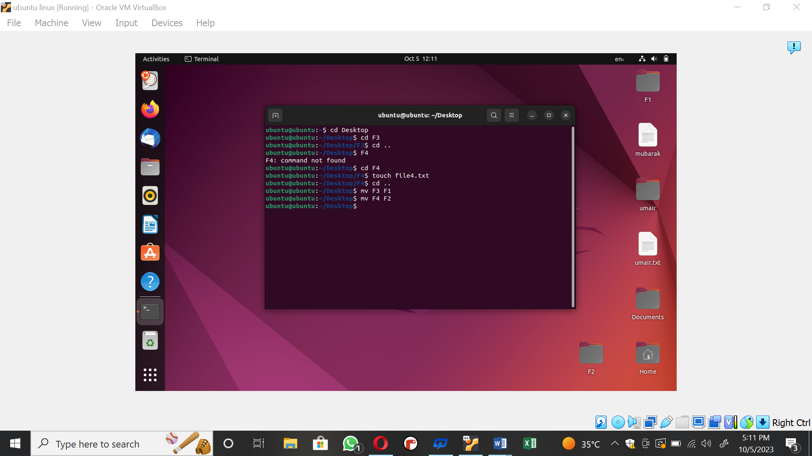

**Copy F3 directory to F4**

